**SQL Quaries**

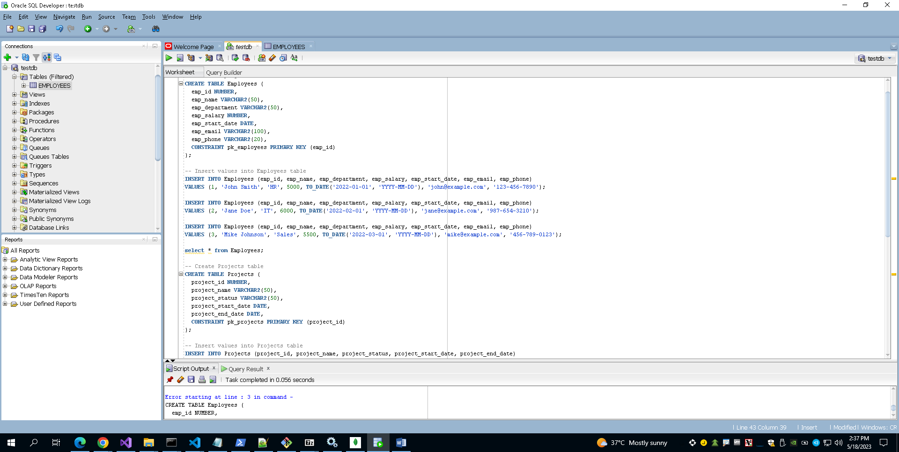Create Employee Table

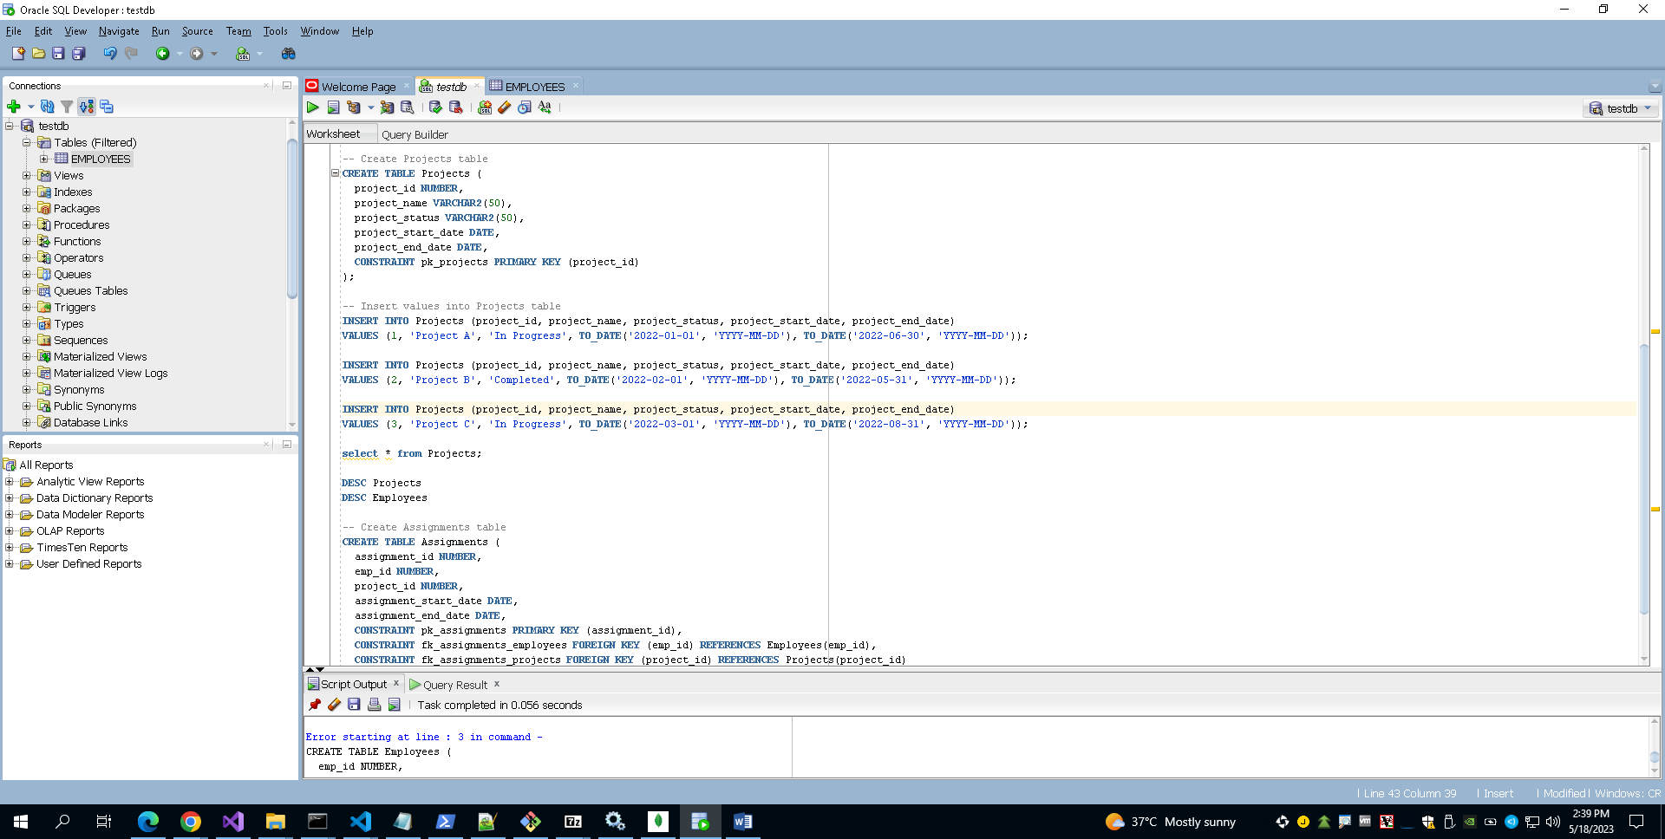Create Project Table

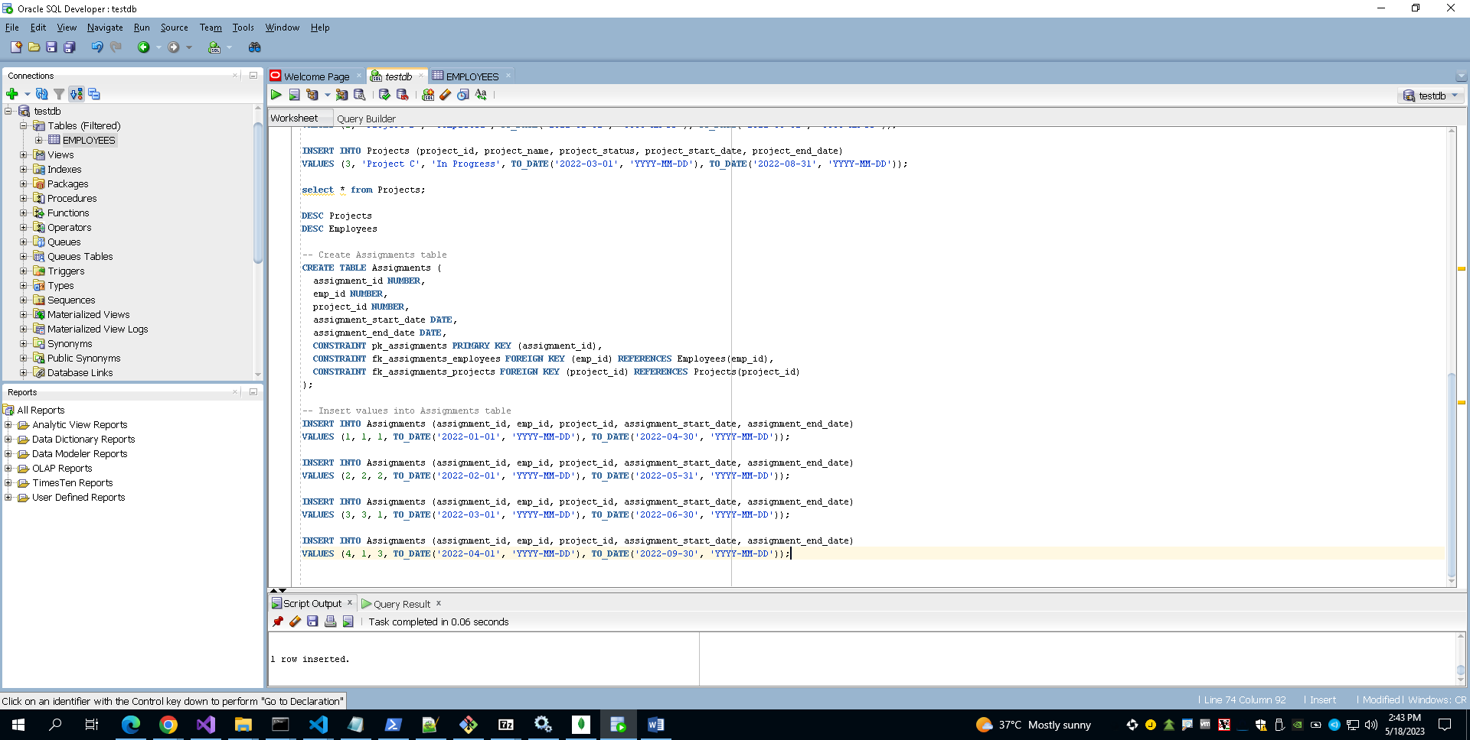Create Assignments Table

**Query a: A join of three or more tables – you should consider various types of join in this query (e.g. inner join, left/right/full outer joins, etc.) and the query must include a restriction on the rows selected**

1. **Inner Join**

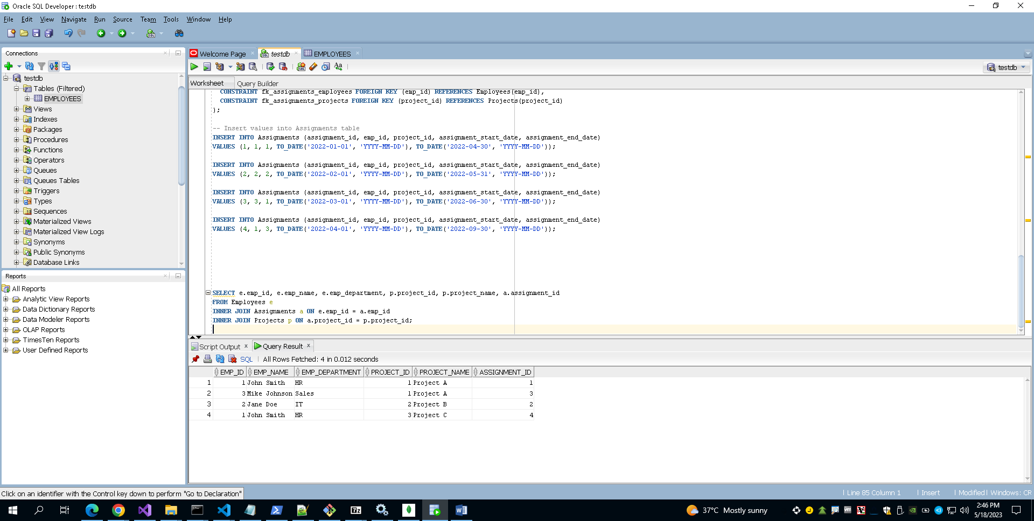

1. 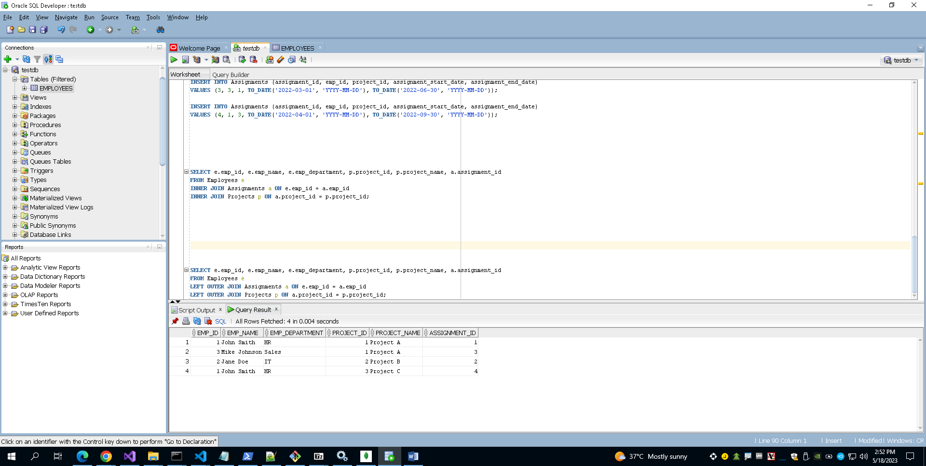**Left Outer Join**
2. 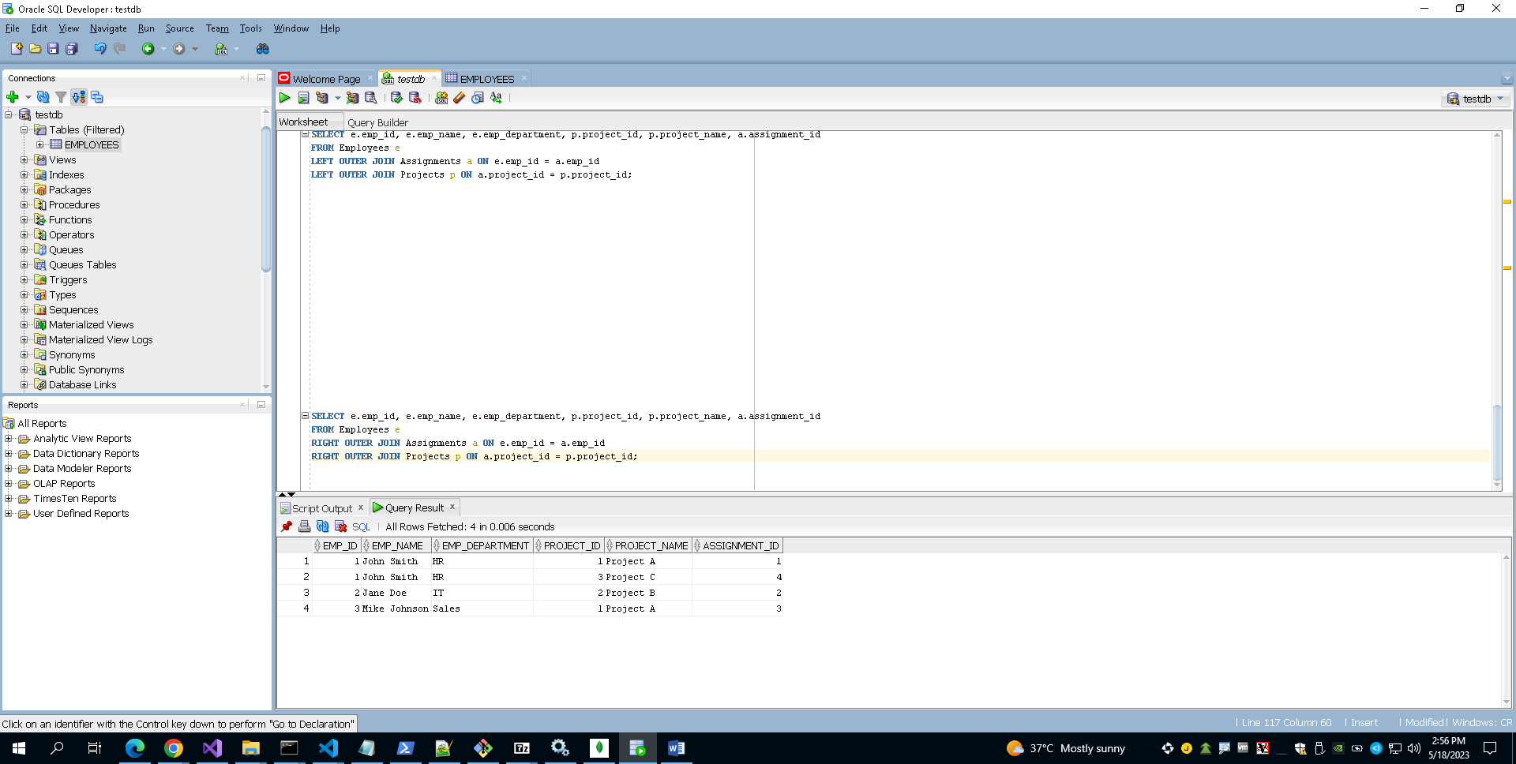**Right Outer Join**
3. 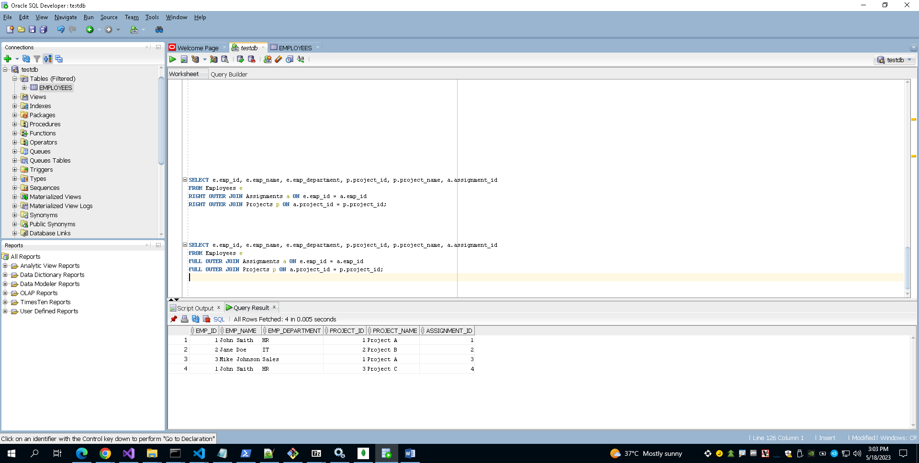**Full Outer Join**

**Query b**: **A query which uses one (or more) of the UNION, DIFFERENCE or INTERSECT operators**.

1. 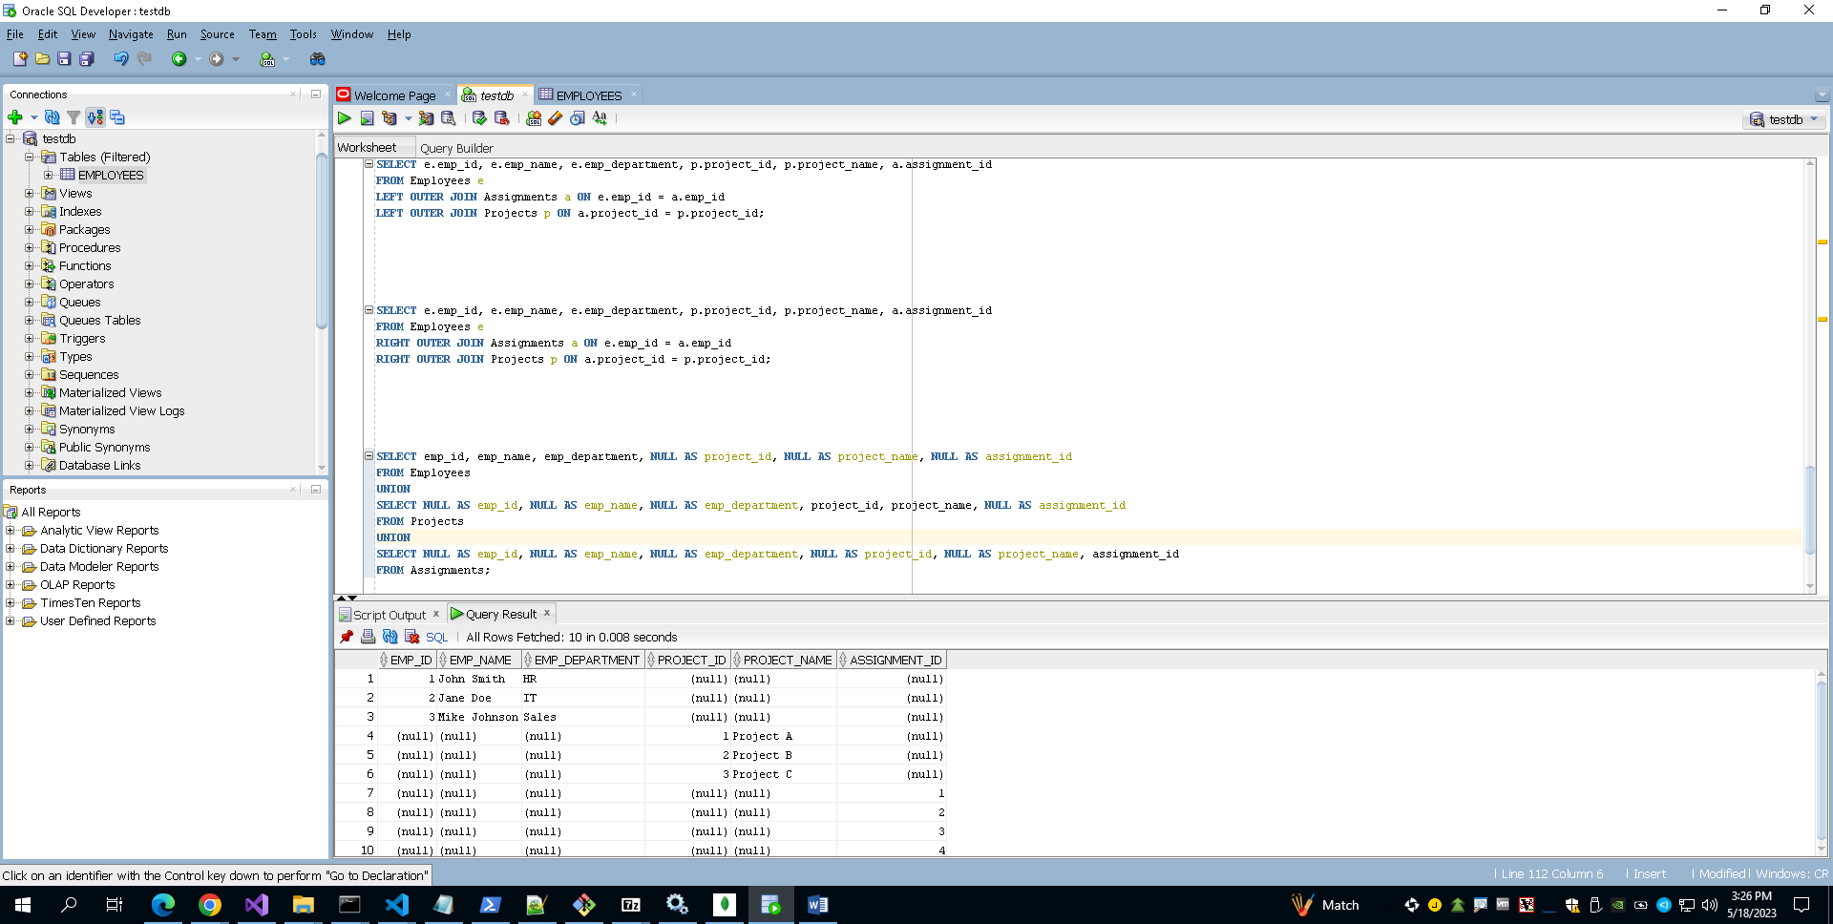**Use of Union**

**Query C:**

**A query which requires use of either a nested table or subtypes**

In this query, we are selecting the product_id, product_name, and the individual item details (item_id, item_name, and quantity) from the "Hardware" table. The TABLE() function is used to treat the nested table "items" as a regular table. We then use the CROSS JOIN to combine each row of the "Hardware" table with the corresponding rows from the nested table.

Executing this query will provide a result set that includes each product along with its associated item details from the nested table.

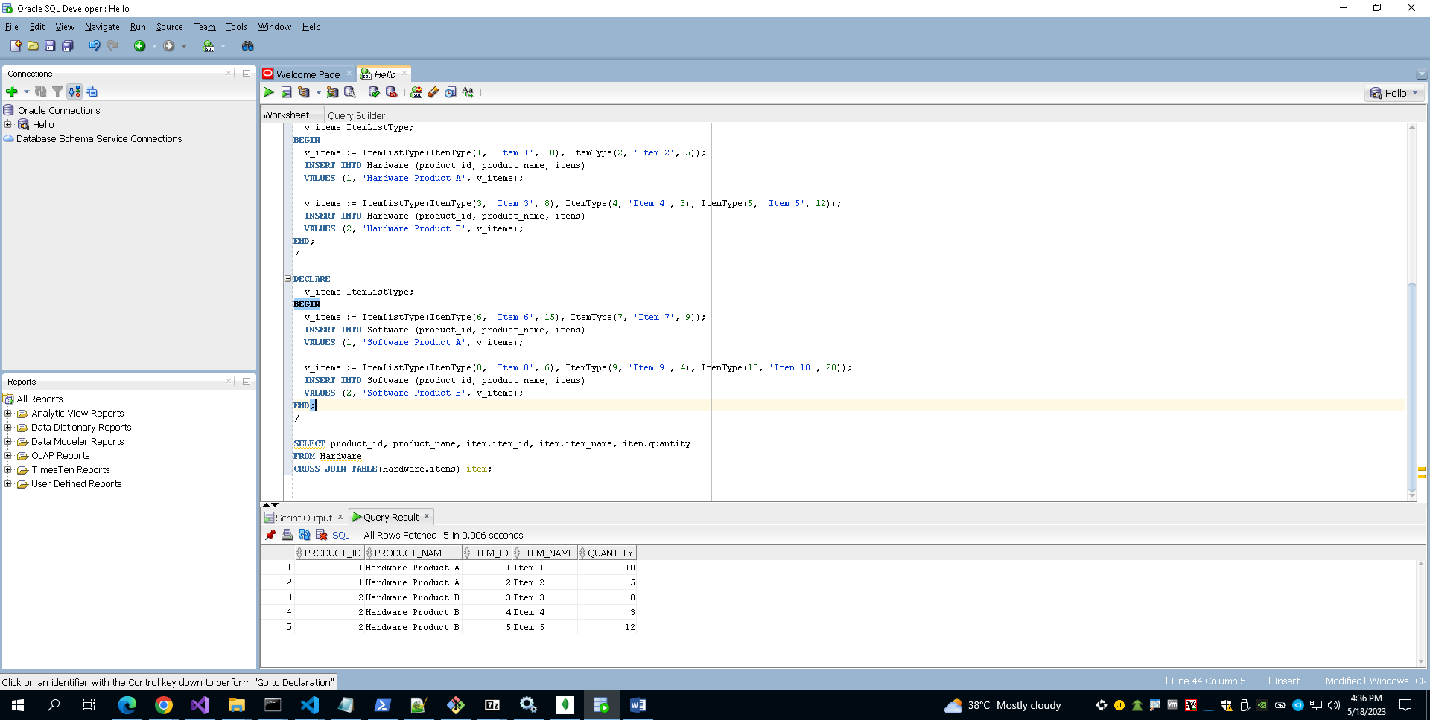

**Query D: A query using temporal features (e.g., timestamps, intervals, etc.) of Oracle SQL**

**Create YourTable for timestamps use**

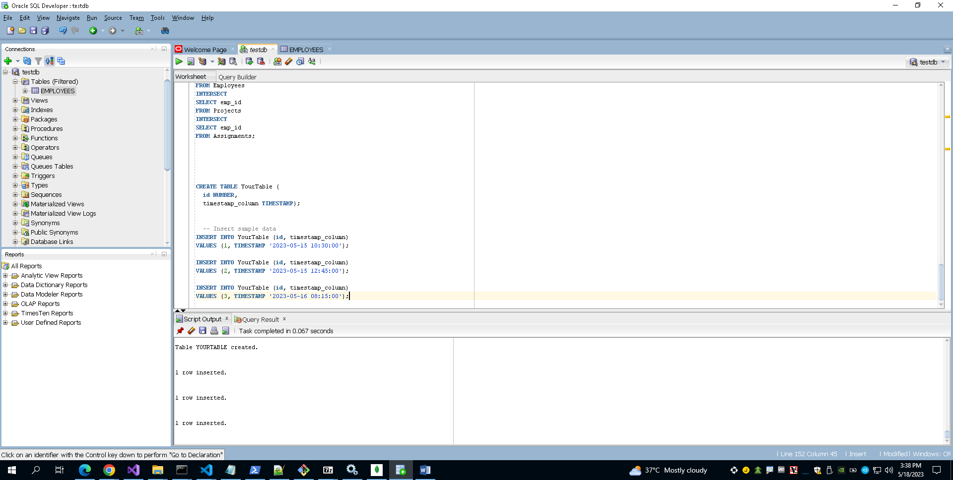

* 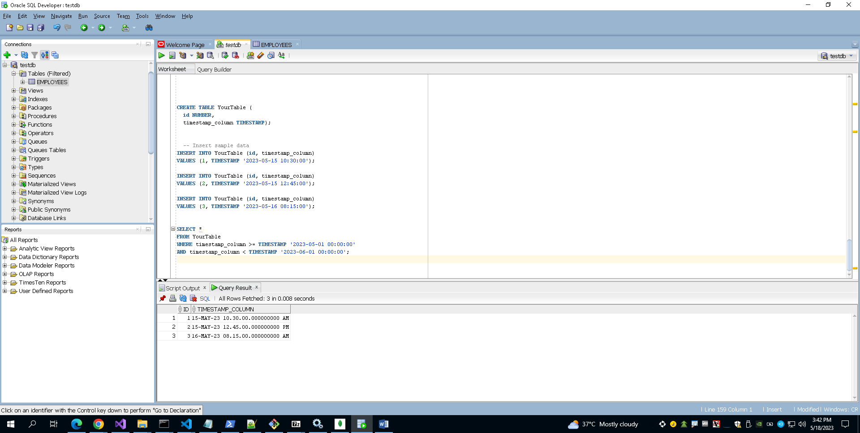**A query using temporal feature of timestamps of Oracle SQL**
* **A query using temporal feature of Intervals of Oracle SQL**

(No output because all the Interval in less than one day as mention in above table’s content)

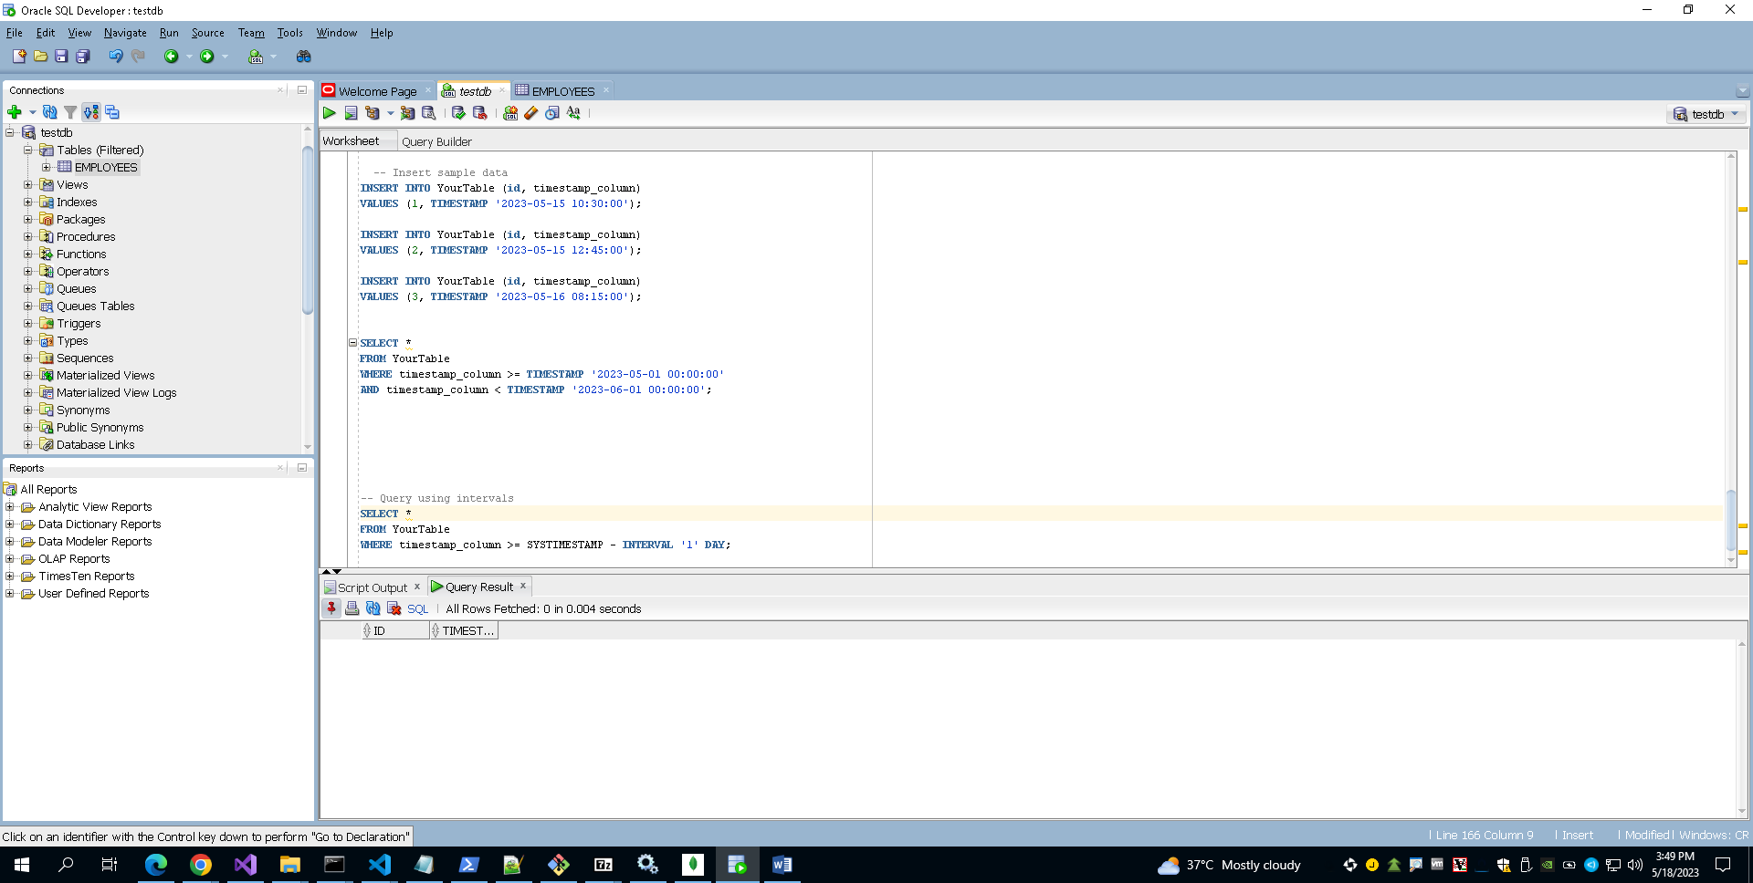

**Query e: A query using OLAP (e.g., ROLLUP, CUBE, PARTITION) features of Oracle SQL**

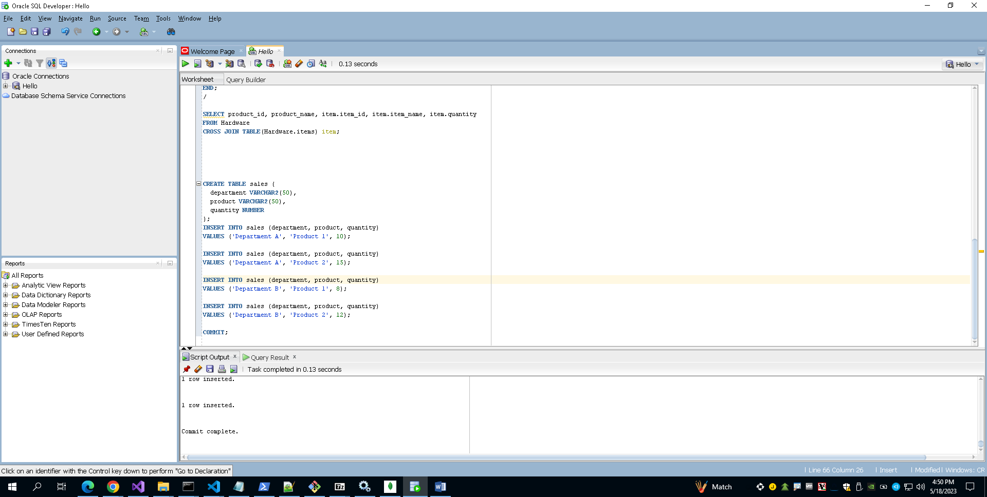TABLE SALE

1. **ROLLUP**

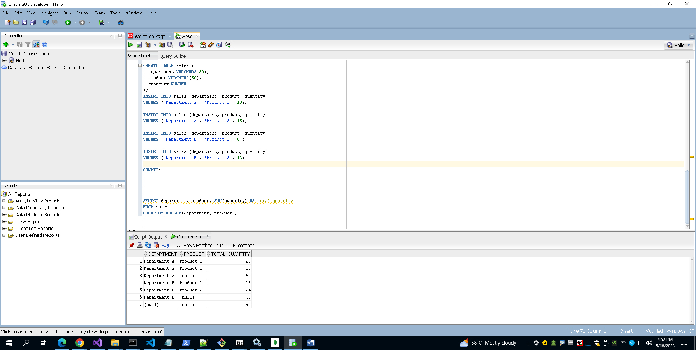

1. **CUBE**

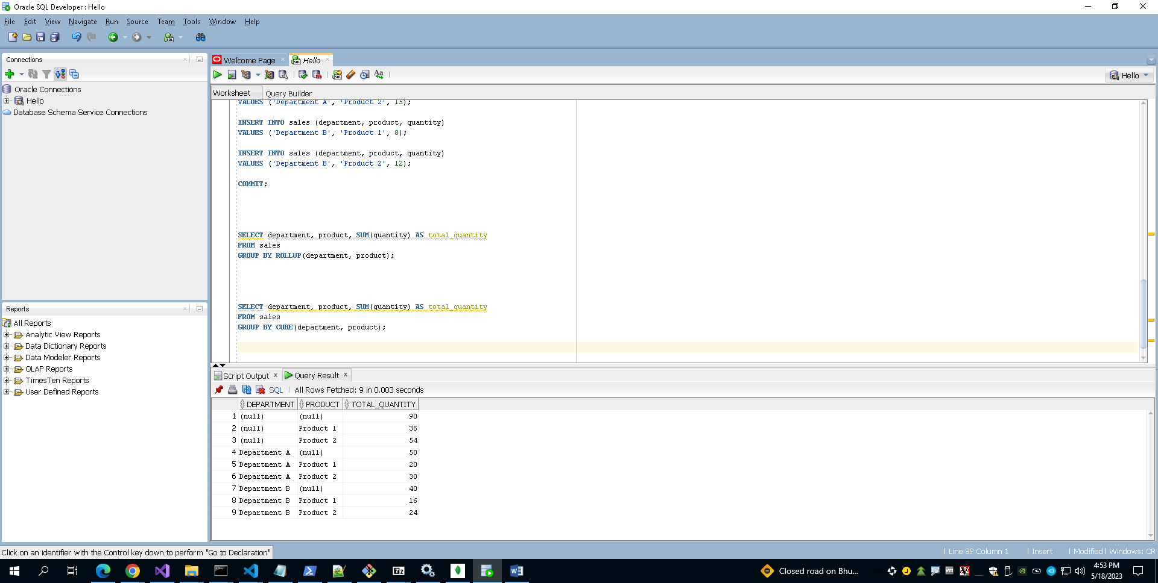

1. **PARTITION**

